22/3/11 Rev. 1 Confidential
Avi Teken

- Objectives
  - Allowing full access to all parameters is big risk we would like to avoid in order to avoid mistakes and to prohibit unneeded parameters change.
  - Many problems in the field are sourced by wrong parameters value.
  - Five hierarchy levels are too many especially when it is unused and there is no way to lock the access to unpermitted users.
- Currently method
  - Currently there are 5 defined hierarchy levels in the parameter manager mechanism.
Mostly, only the Super User level is been used by all parties i.e. CSE, R&D, production, since it contains all the parameters and it is the most “convenient” way of working.
  - In the current method, when opening the PM, only parameters refer to the low level are shown (See figure 1 below). In order to change the selection to a higher level, a keyboard combination Alt+Ctrl+P should be typed. This opens a new selection window allowing to select the required level out of five (See figure 2 below).
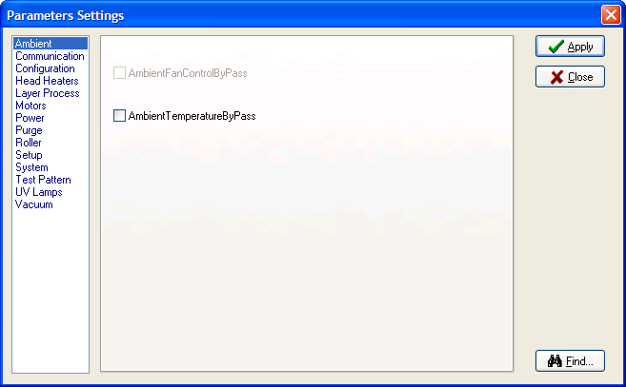
Figure 1

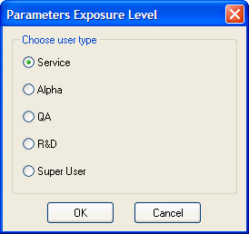
Figure 2

- New Method SRS
  - Only two levels are required instead of the existing five..
  - New levels are needed: Basic and Advanced (Those names are not important since it will not be written in the application).
  - When opening the PM, all parameters of the q2rt will be shown in the GUI. The Basic level parameters will be enabled while all other parameters will be disabled.
  - The basic level parameters will contain a defined list of parameters that is required during a standard work of CSE in the field or in the production floor by the production integrations.
  - The Basic level parameters will be defined in a new *.cfg file called: BasicPMLevel.cfg (This name can be change if better name will be suggested). This file will be located in: C:\Connex500\ServiceTools\ParametersExportAndImport (This is the best location I currently found but it is open to new suggestions. It is important this file will not be in a common location)
  - The BasicPMLevel.cfg will contain checksum in order to prevent it from been easily changed. A standard tool to recreate the checksum is required for R&D usage and needs to be created by the SW team.
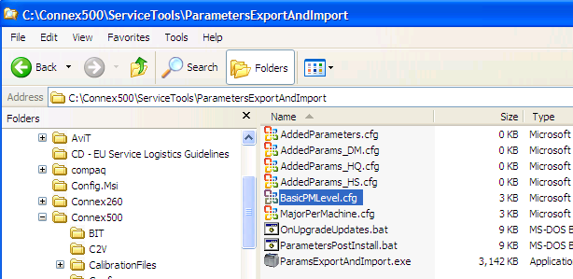
Figure 3: BasicPMLevel.cfg location

  - When the PM main window is opened with the Basic level loaded, a keyboard combination of Shift+P will open a new window asking for a password. Entering the correct password will change the loaded level loaded from Basic to Advance.
  - Oncea password is typed and the Advance level is lunched, any close and reopening of the PM will automatically enter into the Advance level. This will be change when the application will be closed or when the user will exit
  - Any new parameter in any future SW version should be define

